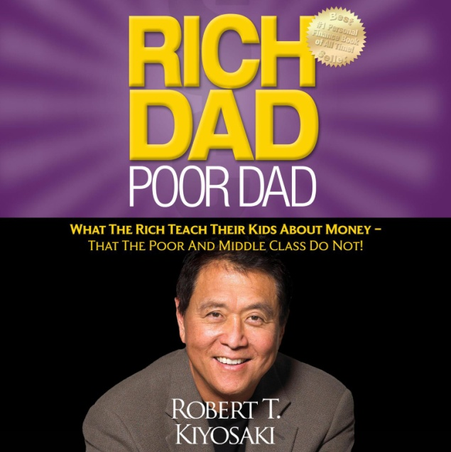`

*RICH DAD AND POOR DAD*

**When I first discovered**[***Rich Dad, Poor Dad***](https://www.amazon.com/gp/product/1612680011/ref=as_li_tl?ie=UTF8&tag=passiveinc03d-20&camp=1789&creative=9325&linkCode=as2&creativeASIN=1612680011&linkId=ff216b3fdb2cfae806cfaf2e683ffb77)**, I was well into the last year of my residency. I couldn’t put it down, and I’m not exaggerating when I say that it completely changed my life. It was also probably the first non-medical book I had read since I was introduced to the works of Malcolm Gladwell during medical school.**

|  |  |  |  |  |  |
| --- | --- | --- | --- | --- | --- |
|  |  |  |  |  |  |
|  |  |  |  |  |  |